**9. PSK MODULATION AND DEMODULATION**

**9.1 Objective**

To analyze a PSK modulation system and interpret the modulated and demodulated waveforms.

**9.2 Hardware Required**

PSK Trainer Kit

Dual Trace oscilloscope-POS-2020

**9.3 Introduction**

Phase shift keying is a modulation/data transmitting technique in which phase of the carrier signal is shifted between two distinct levels. In a simple PSK(ie., Binary PSK) un-shifted carrier Acosωt is transmitted to indicate a 1 condition, and the carrier shifted by 1800 ie., – Acosωt is transmitted to indicate as 0 condition.

**S(t)= Acos 2πfct for Binary 1**

**Acos (2πfct +π) for Binary 0**

**WIRING /TRAINER KITDIAGRAM**

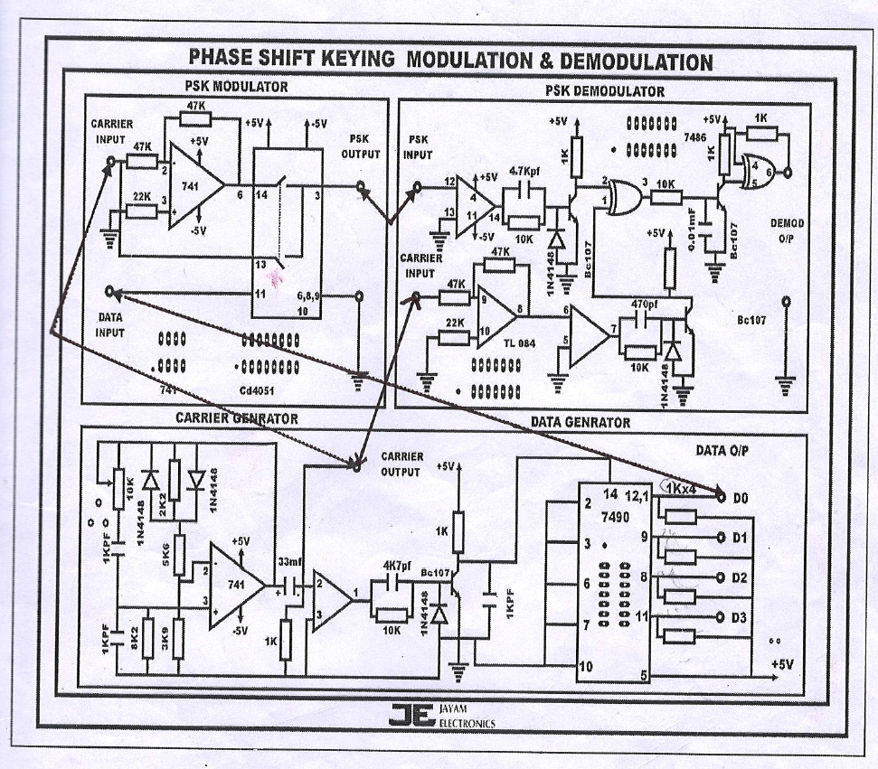

**Fig 9.1 Wiring Diagram for PSK Modulation and Demodulation**

**9.4 Pre Lab Questions**

1. What is BPSK?
2. Draw the truth table, Phasor diagram, Constellation diagram of BPSK.
3. What is bit error rate and give the expression for bit error Probability of BPSK.
4. Compare binary PSK with QPSK.
5. Write the applications of PSK.

**9.5 Lab Procedure**

1. Connect the trainer to mains and switch on the power supply.
2. Observe the output of the carrier generator using CRO,it should be an 17KHZ sine with 5Vpp amplitude.
3. Observe the various data signals(4KHZ and 8KHZ) using CRO

**Modulation**

1. Connect carrier signal to carrier input of the PSK modulator.
2. Connect data signal say 4KHZ from data source to data input of the modulator.
3. Keep CRO in dual mode and connect CH1 input of the CRO to data signal and CH2 to the output of the PSK modulator.
4. Observe the PSK output signal with respect to data signal and plot the waveforms.

**Demodulation**

1. Connect the PSK output to the PSK input of the demodulator.
2. Connect carrier to the carrier input of the PSK demodulator.
3. Keep CRO in dual mode and connect CH1 to data signal (at modulator) and CH2 to the output of the demodulator.
4. Compare the demodulated signal with the original signal. By this we can notice that there is no loss in modulation and demodulation process
5. Repeat the steps 5 to 11 with different data signal ie., 8KHZ

**9.6 Model Graph**

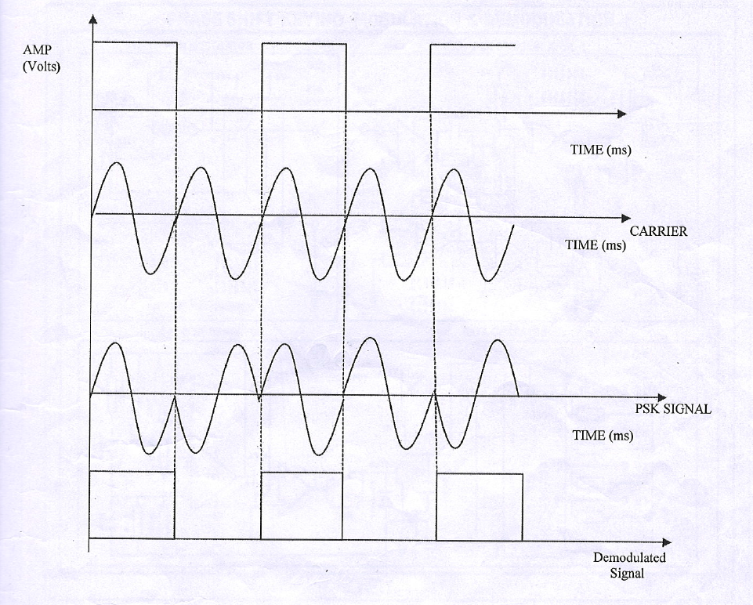

**Figure 9.2 PSK Waveforms for different data input signals**

**9.7 Observation-Hardware**

**PSK Modulation**

|  |  |  |
| --- | --- | --- |
| **Signal Name** | **Amplitude** | **Time Period** |
| **Carrier signal** |  |  |
| **Data source**  For 4KHz  For 8KHz |  |  |
| **Modulated output**  For 4KHz  For 8KHz |  |  |

**PSK Demodulation**

|  |  |  |
| --- | --- | --- |
| **Signal Name** | **Amplitude** | **Time Period** |
| **Demodulated output**  For 4KHz  For 8KHz |  |  |

**9.8 Post Lab Questions**

**1.** Differentiate between coherent and non-coherent detection

2. What is the maximum Bandwidth of BPSK system?

3. What is the main advantage of M-ary PSK?

4. Represent the M-ary PSK signal mathematically.

5. Show the PSK modulated waveform for the message 10010110.

**Lab Result**

Thus the PSK modulation and demodulation were performed.